**INSTALLATION PROCEDURE**

**Steps to install python**

**Step-1:** Download python from the website <https://www.python.org/>

**Step-2:** After downloading the python executable file. Double click on it and click run as

administrator.

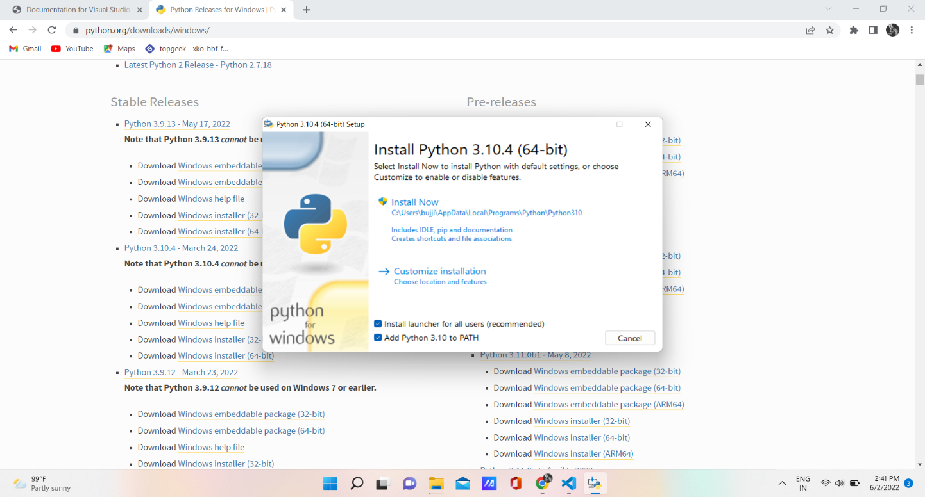

**Step-3:** Now click on Install Now to install the python in your system and it starts the

installation process.

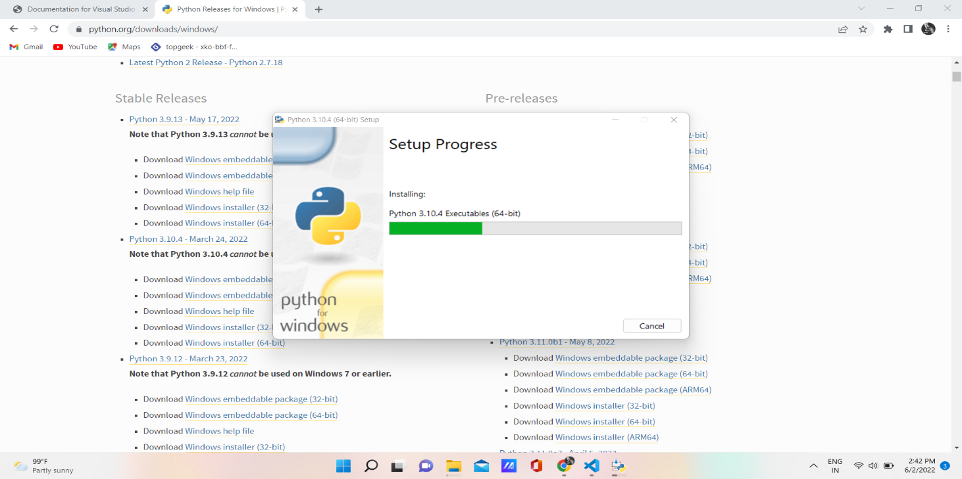

**Step-4:** After the completion of the installation process, it displays the dialog box as shown

below :

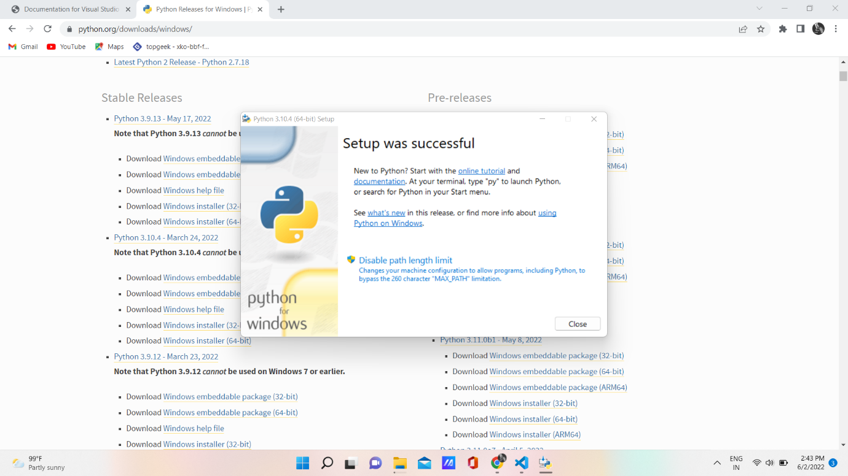

**Step-5:** click the close button and check whether the python is installed or not, by opening

the Windows command prompt and type python.

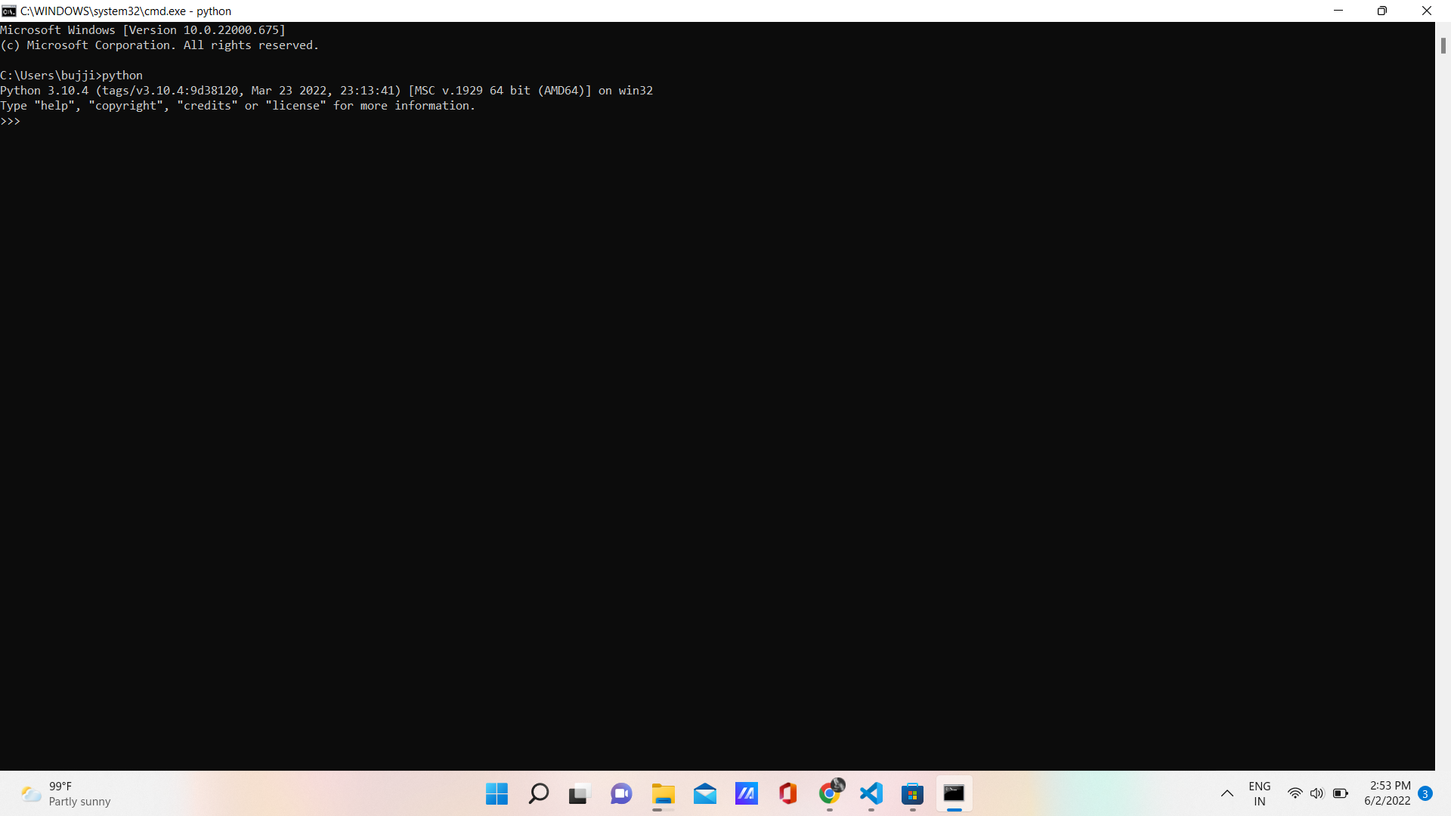

**Step-6:** Python is successfully installed and checks whether the pip is verified or not. Open

the command prompt and type pip.

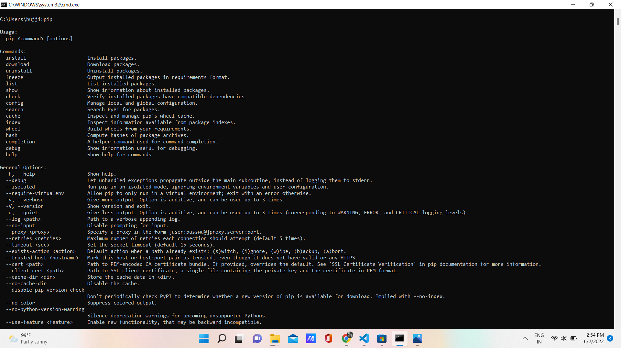

**Steps to install Visual Studio Code Editor:**

**Step-1:** Download the visual studio code editor from the website <https://code.visualstudio.com>

and click the download button to download the respective version. After downloading

double click on to run the setup process.

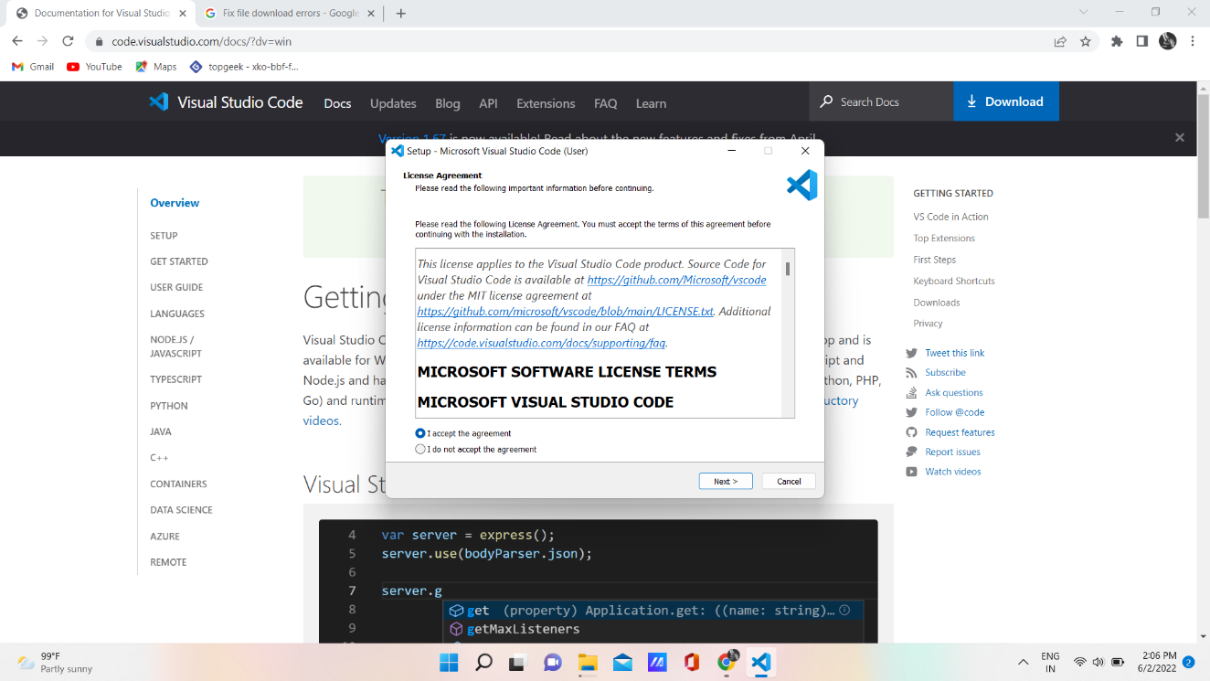

**Step-2:** accept the agreement and choose the installation location as per your request and

Click on next to install the process.

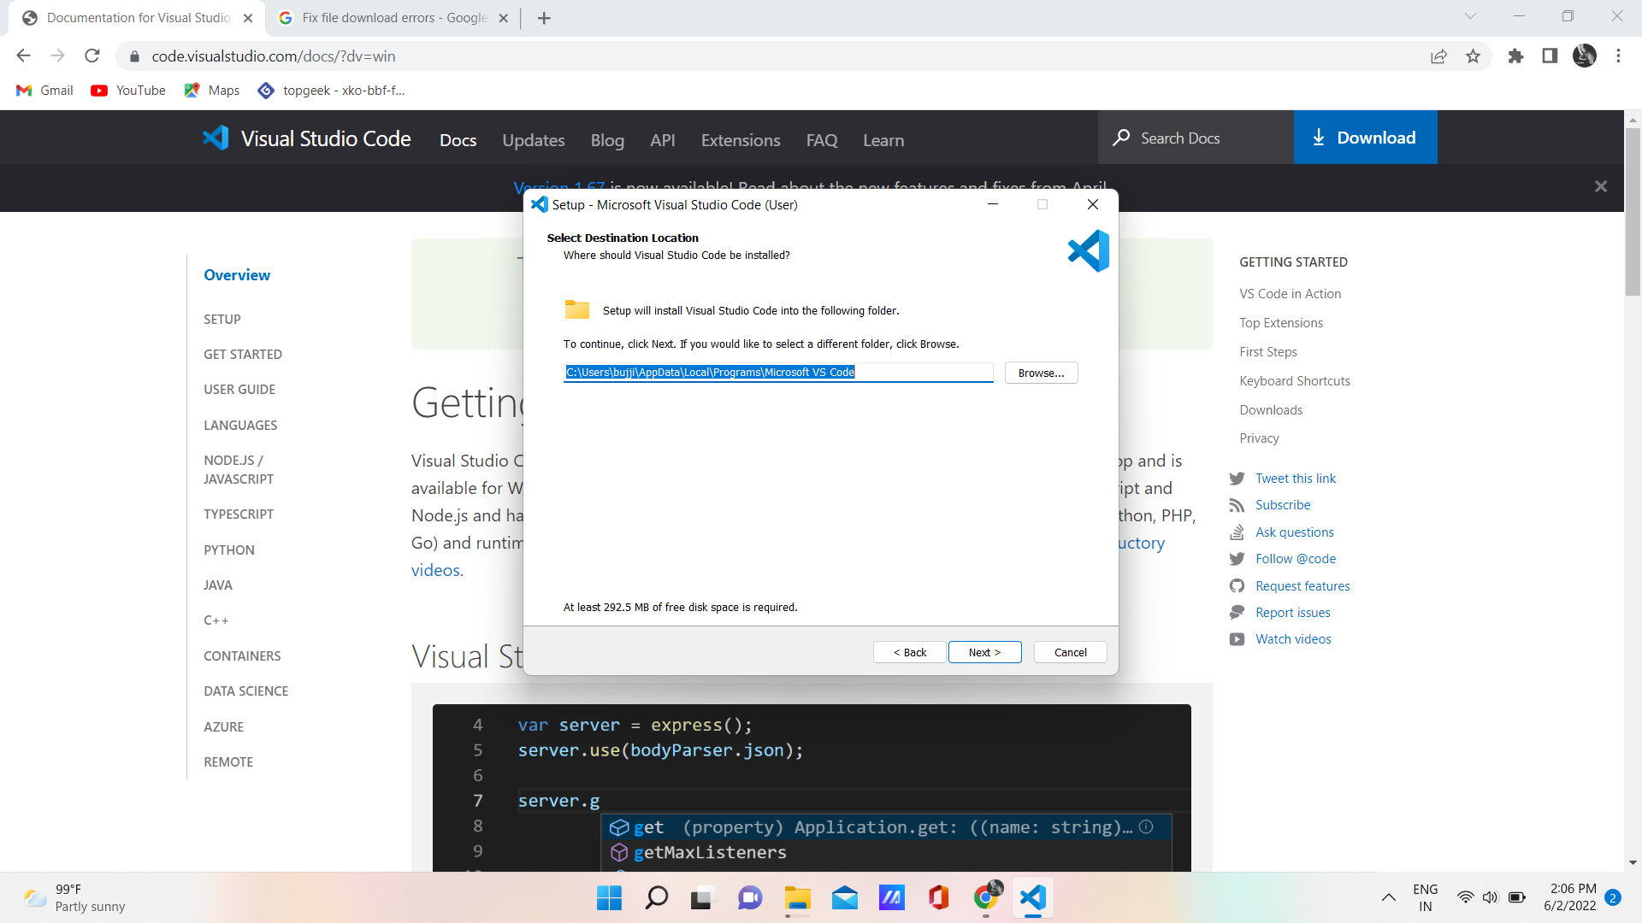

**Step-3:** After selecting the location, the installation process continues and the visual studio

code was ready to run and click on finish to open launch visual studio code.

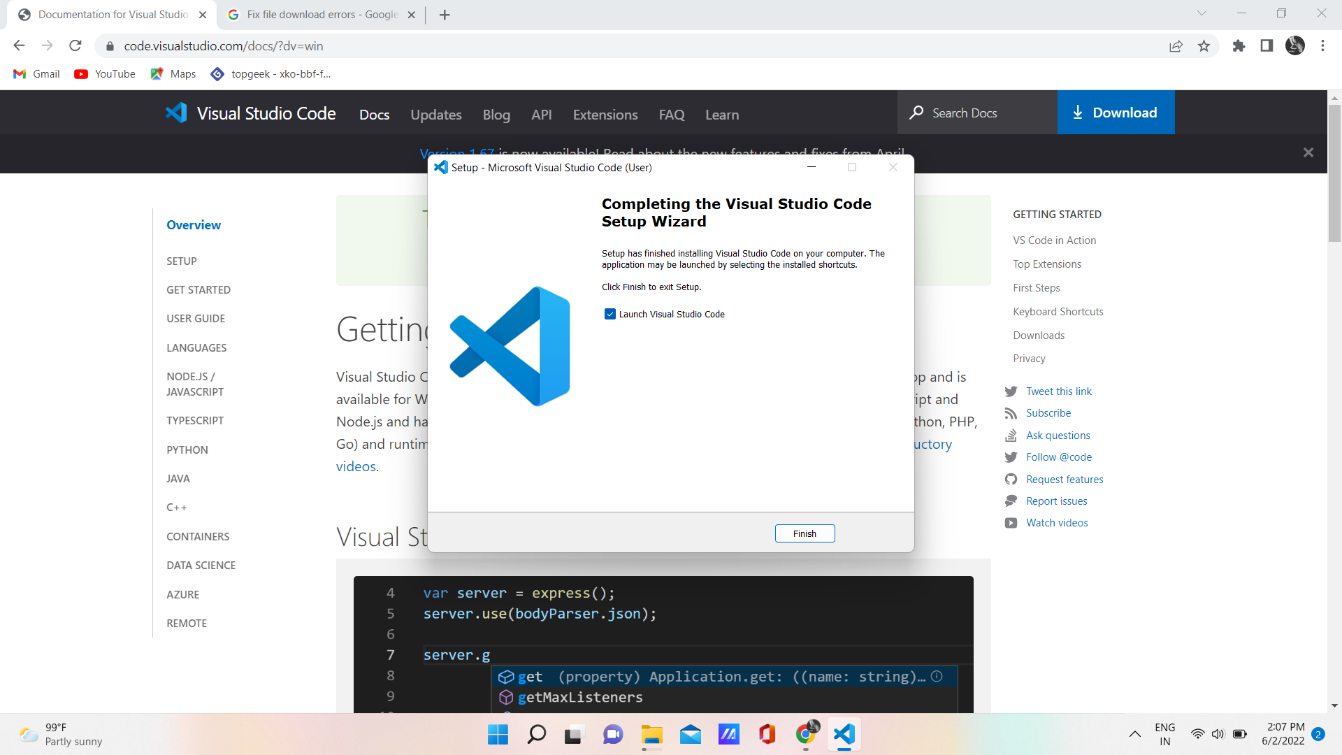

**Steps to run Asset Price Prediction**

**Step-1:** Copy the project folder to your system and we need a virtual environment to install

Django framework. We can install a virtual environment by using the following

steps:

* Open the windows command prompt and change the path to the project

folder path by using the command “cd”.

* Enter the following command to create a virtual environment i.e.,

py -3 -m venv .venv

* After that change directory to .venv folder by using cd command

cd .venv

* Again change the directory to the Scripts folder and type activate to activate the virtual environment.

cd Scripts\activate

* The command will activate the virtual environment and type the following command to install Django

pip install Django

* This will install the Django in the virtual environment.

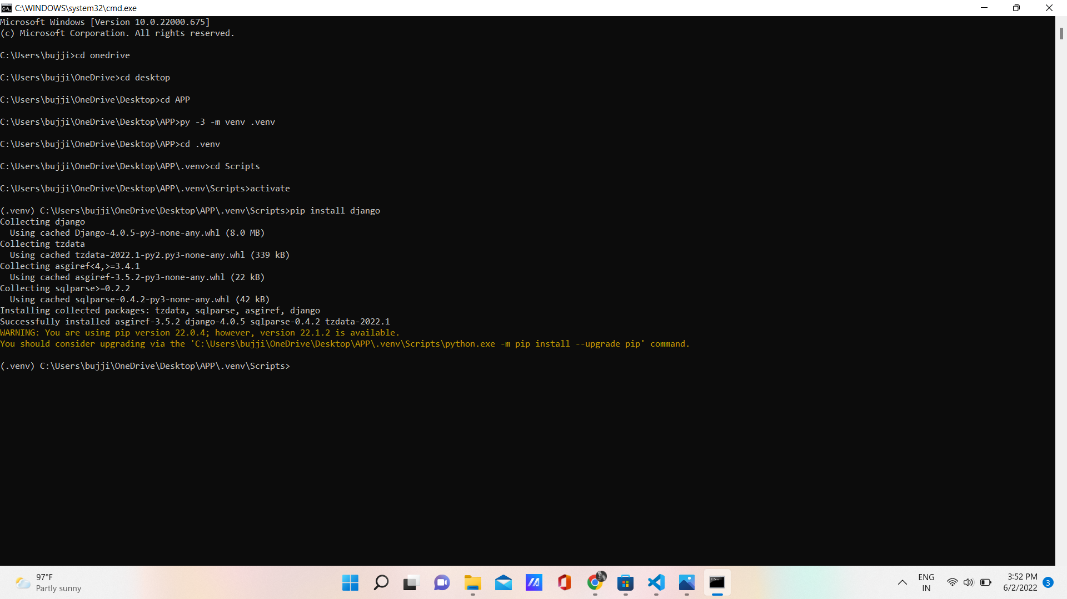

**Step-2:** After that, import the project folder in the Visual Studio code editor, by clicking the open folder option in the File menu in visual studio code and select the folder.

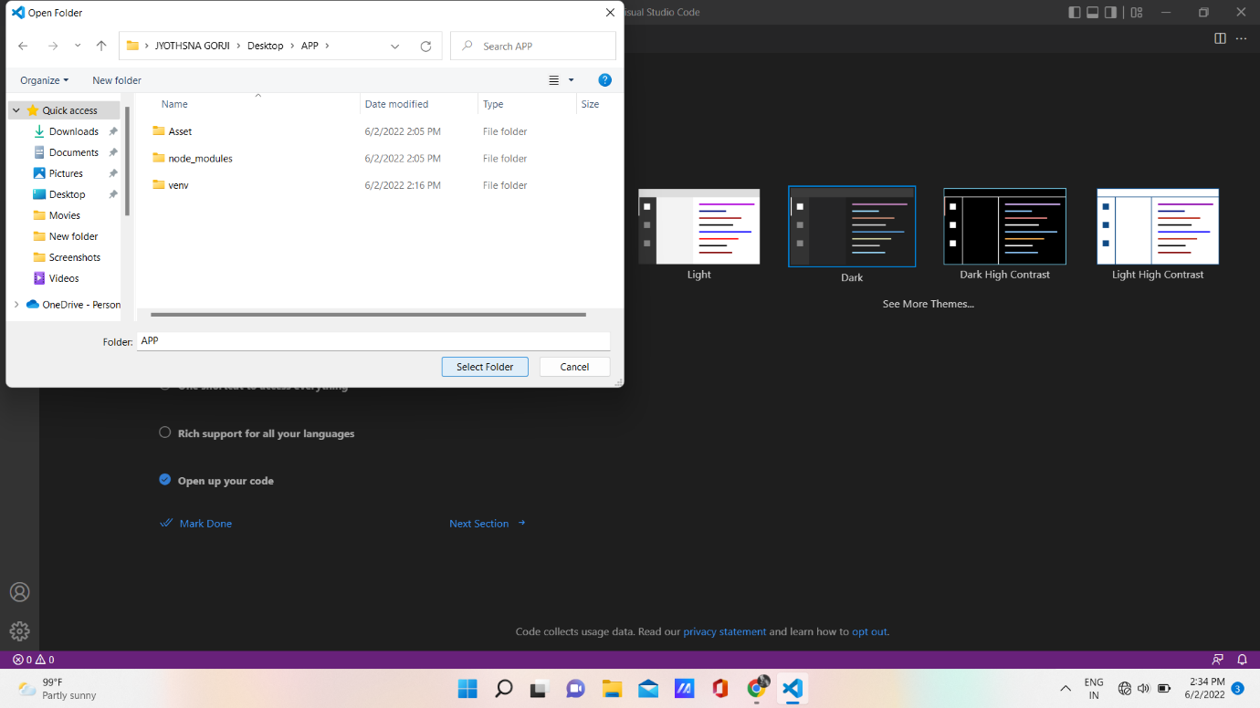

Step-3: After opening the project folder, we install some modules to run the project. For this,

we list all the modules that are used in this project in a text file named requirements.

Here is the requirement.txt file

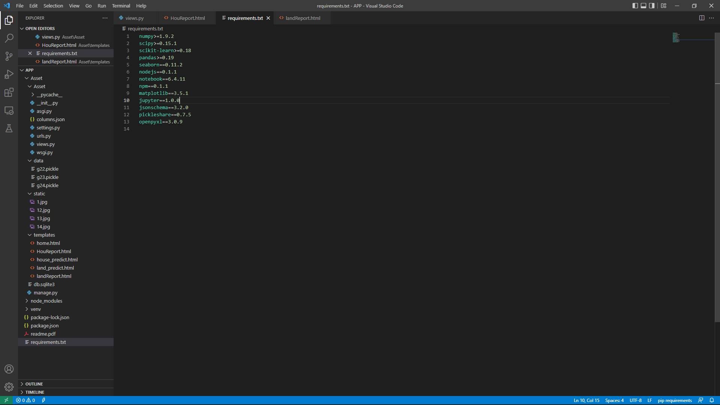

**Step-4:** Enter the below command to install all the modules at a time. Open the new terminal

in the visual studio code and enter the following command

pip install -r requirements.txt

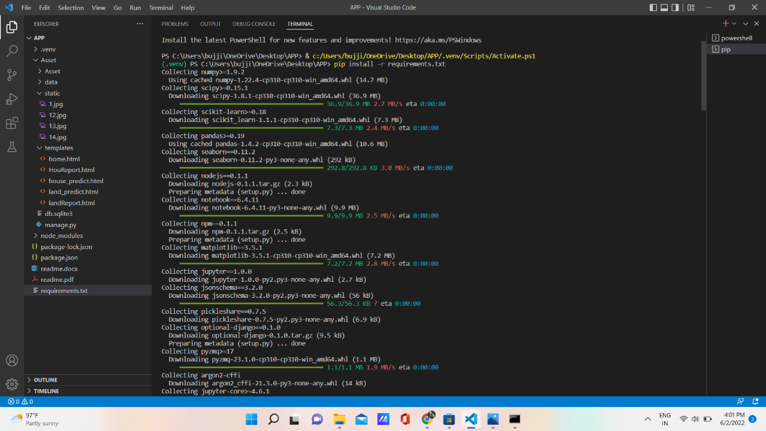

**Step-5:** After successful installation of packages. Follow the below steps to run the website

in the local host.

* Open the new terminal and change the directory to the Asset folder.

cd Asset

* Enter the following command to run the server

python manage.py runserver

* It starts the local sever and gives a link to the website. Press ctrl +right click on the link, it will redirect to the website in the browser.

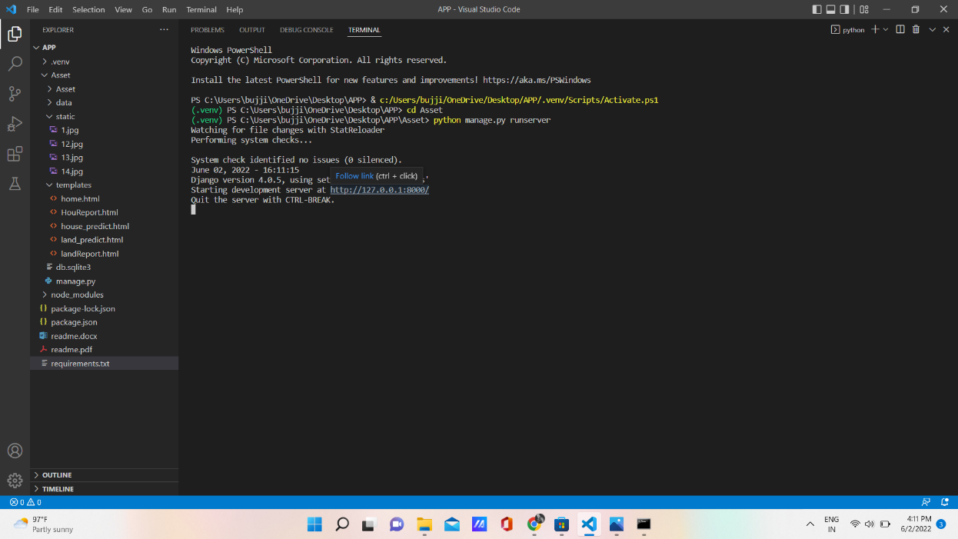

**Step-6:** To stop the local server press ctrl + c or close the tabs of the visual studio code.

**Step-7:** Finish.